|  |  |
| --- | --- |
| **Name of the Event** | 4th iStart Divisional Level Outreach Workshop at Bikaner |
| **Date(s)** | 28th April 2022 |
| **Time** | 9:30 AM – 4:30 PM |
| **Venue** | Meeting Hall, UIT |
| **Agenda** | Outreach and Awareness Workshop |

|  |
| --- |
| **Brief Description of the Event** |
| iStart organized its 4th divisional level Outreach workshop for startups, rural innovators and SHGs.  The aim of this workshop was to create awareness among entrepreneurs, startups, rural innovators, and to impart knowledge regarding the iStart program. This workshop provided participants with a clear understanding of iStart Rajasthan Program, iStart rural program, and various funds, policies, and benefits associated with them along with interactive session.  In the first session iStart mentors Manish Bhatra, Umang Purohit, and Abhishek Patodia gave information about benefits provided by iStart Rajasthan and company formation, marketing, branding. They also shared their thoughts on MVP prototype, product fit in the startup ecosystem and shared their experience with the Bikaner based startups. Umang Purohit shared her thoughts with the young girls of Bikaner.    Second session of the outreach workshop with rural innovators was begun by iStart mentor Amresh Nagar by interacting with the participants and giving them knowledge about the startup ecosystem.  Discussion with Prof Ambarish S. Vidyarthi, Hon’ble Vice Chancellor Bikaner technical university was done where he encouraged participants to pursue entrepreneurship. This was followed by a panel discussion on the topic “Challenges faced by rural innovators and SHGs”.  Neeraj K Paswan, Divisonal commissioner of Bikaner, also attended the workshop and motivated all the participants and startups to enter the startup ecosystem of Rajasthan. He was given memento by Tapan Kumar on behalf of iStart team Rajasthan.  Workshop was brought to conclusion by Tapan Kumar. |
| **Agenda** |
|  |
| **Outcomes** |
| More than 200 attendes were given information about iStart programme.  Young entrepreneurs were given information about different schemes related to startups and other schemes which are launched by Government of Rajasthan.  New iStart incubator is going to be established in the state to help young entrepreneurs and women in the related field.  Workshop included an informative talk about entrepreneurships and challenges faced by successful startup founders from the region. |
| **Event Pictures** |
|  |
| **Social Media Coverage** |
|  |

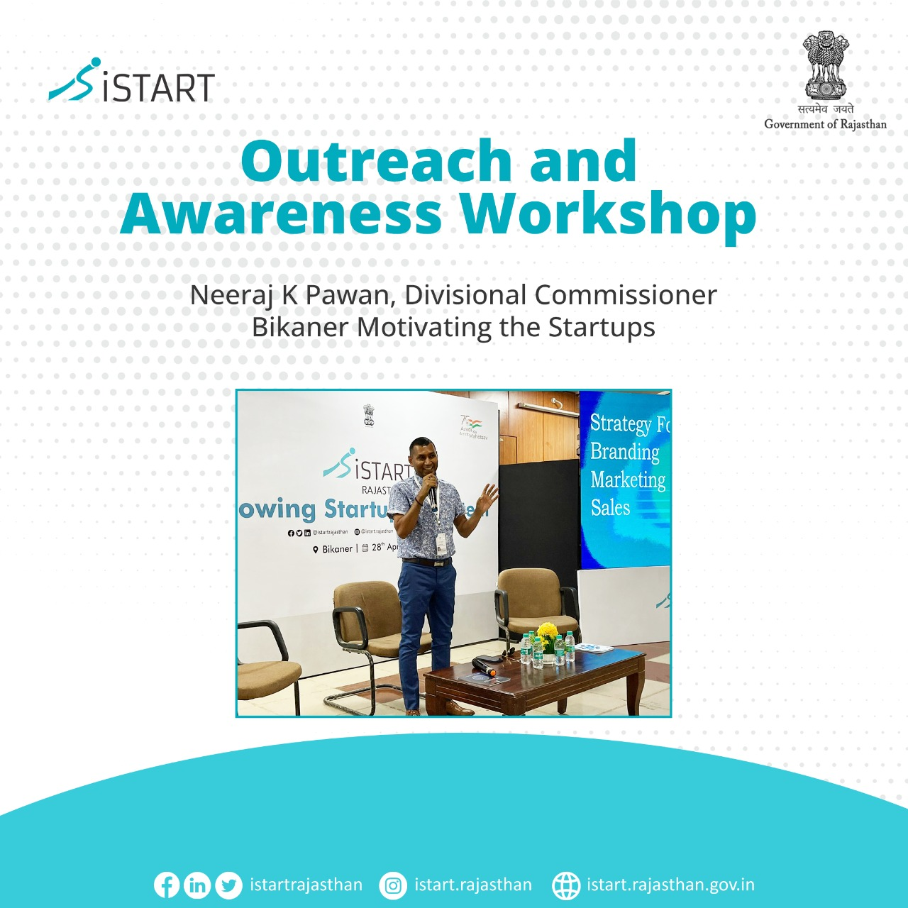

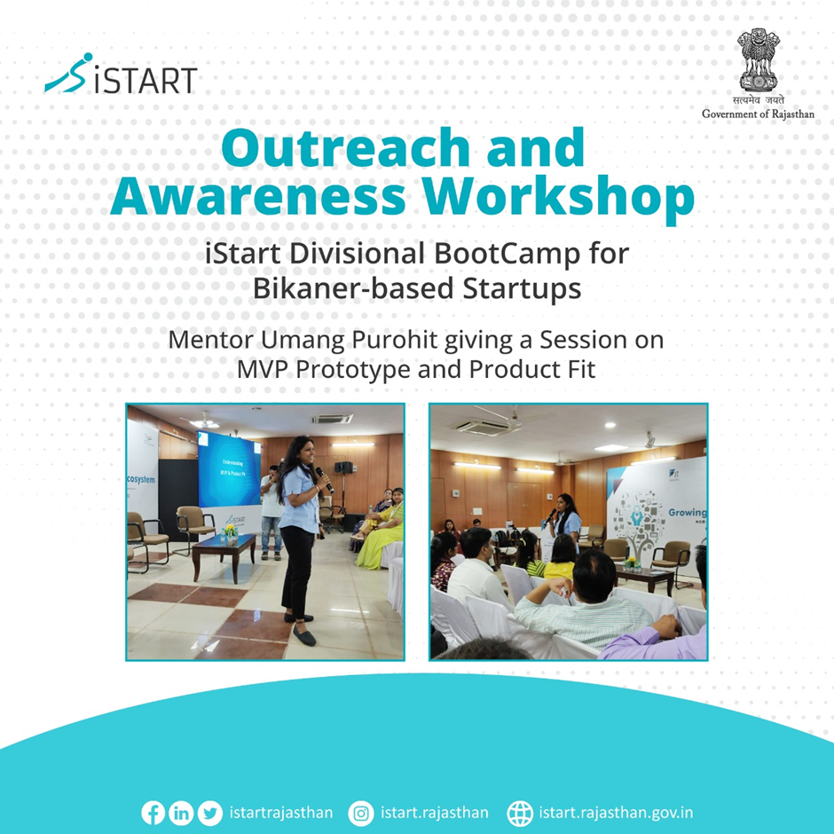

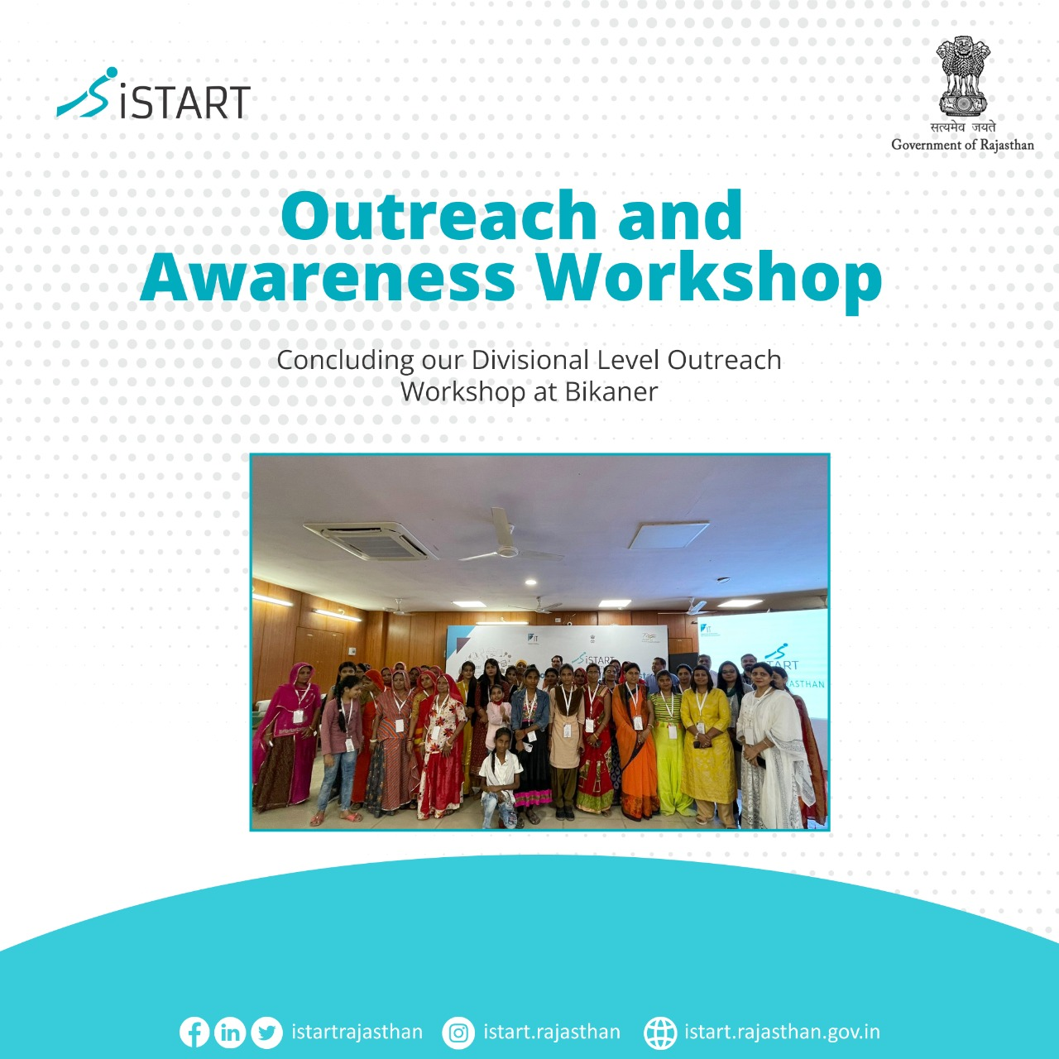

|  |
| --- |
| **Press Coverage** |
| 6.1 Dainik Navjyoti, 29th April 2022        6.2 Patrika, 29th April 2022    6.3 Dainik Bhaskar, 29th April 2022 |

|  |  |  |  |  |  |
| --- | --- | --- | --- | --- | --- |
| **Session 1** | | | | | |
| **Sr No** | **Name** | **school/college** | **category** | **Mobile no** | **Email Id** |
| 1 | Dr. Mm Sheikh | Lohia College Churu | Mentor | 9414254762 | mmskhreddifmail.com |
| 2 | Rajesh | Lohia College Churu | Student | 8769036638 | [rm43076@gmail.com](mailto:rm43076@gmail.com) |
| 3 | Prahalad | Lohia College Churu | Student | 9928428736 | [prahaledrjr2001@gmail.com](mailto:prahaledrjr2001@gmail.com) |
| 4 | Ranajana Gurjar | Lohia College Churu | Student | 7877109747 | [ranjanagurger6834000@gmail.com](mailto:ranjanagurger6834000@gmail.com) |
| 5 | Shruti Sharma | Lohia College Churu | Student | 9929777210 | [shrutisharma5427@gmail.com](mailto:shrutisharma5427@gmail.com) |
| 6 | Suman Megwal | Lohia College Churu | Student | 7878348617 | [gogasar9@gmail.com](mailto:gogasar9@gmail.com) |
| 7 | Punit Kalwani | Lohia College Churu | Student | 9468724365 | [puneetworldking@gmail.com](mailto:puneetworldking@gmail.com) |
| 8 | Sachin Meena | Lohia College Churu | Student | 9001114707 | [sachinmeena09012000@gmail.com](mailto:sachinmeena09012000@gmail.com) |
| 9 | Kavita Jaat | Lohia College Churu | Student | 6377144361 | [jat43770@gmail.com](mailto:jat43770@gmail.com) |
| 10 | Ravikant Panwar | Lohia College Churu | Student | 9251807993 | [rkpanwar30mar@gmail.com](mailto:rkpanwar30mar@gmail.com) |
| 11 | Vikram Singh | Lohia College Churu | Student | 7742622809 | [vikramsingh17051997@gmail.com](mailto:vikramsingh17051997@gmail.com) |
| 12 | Mamta | Lohia College Churu | Student | 6377144361 | [dadamanimamtasaran@gmail.com](mailto:dadamanimamtasaran@gmail.com) |
| 13 | Bharti Meena | Lohia College Churu | Student | 7877065827 | [yogeshmeena724074@gmail.com](mailto:yogeshmeena724074@gmail.com) |
| 14 | Shubhash Soni | Government College Hanumangarh | Mentor | 9887089362 | [shubhash.soni191191@gmail.com](mailto:shubhash.soni191191@gmail.com) |
| 15 | Shri Kiran Dhill | Government College Hanumangarh | Mentor | 7073388189 | [dhillkiran27@gmail.com](mailto:dhillkiran27@gmail.com) |
| 16 | Tanmay Shrimali | Basic Pg College | Student | 9672645192 | [tanmayshrimali78@gmail.com](mailto:tanmayshrimali78@gmail.com) |
| 17 | Ankit Sharma | Rajasthan University | Student | 9664211684 | [ajking1175@gmail.com](mailto:ajking1175@gmail.com) |
| 18 | Mohit Sharma | Rajasthan University | Student | 9509907443 | [mohitsharmaabcd474@gmail.com](mailto:mohitsharmaabcd474@gmail.com) |
| 19 | Sanjay Kumar Bharghav | Saga Manpower | Employee | 9950502961 | [sanjaykumar221026@gmail.com](mailto:sanjaykumar221026@gmail.com) |
| 20 | Amit Sangi | Lugbee Services Pvt Ltd | Employee | 9461471451 | [amitsanghi@lugbee.com](mailto:amitsanghi@lugbee.com) |
| 21 | Anushree | Basic Pg College | Student | 6377012354 | [anushreeranga2018@gmail.com](mailto:anushreeranga2018@gmail.com) |
| 22 | Aardhana Archarya | Basic Pg College | Student | 8003895942 | [aaradahanaacharya0@gmail.com](mailto:aaradahanaacharya0@gmail.com) |
| 23 | Meenakshi Satija |  | Student | 7014629729 | [meenakshisatija28@gmail.com](mailto:meenakshisatija28@gmail.com) |
| 24 | Meenakshi Nahar |  | Student | 7688954611 | [meenakshinaha774@gmail.com](mailto:meenakshinaha774@gmail.com) |
| 25 | Dr Naveen Khatri | Shri Jain Girls Pg College | Mentor | 9414325089 | [drnkhatri5@gmail.com](mailto:drnkhatri5@gmail.com) |
| 26 | Vishal Solanki | Shri Jain Girls Pg College | Mentor | 8209363319 | [vishalsolanki64@gmail.com](mailto:vishalsolanki64@gmail.com) |
| 27 | Megha Deyari | Shri Jain Girls Pg College | Student | 9166627333 | [meghu.dujari97@gmail.com](mailto:meghu.dujari97@gmail.com) |
| 28 | Divya Solanki | Basic Pg College | Student | 9261707176 | [sanjusolanki076@gmail.com](mailto:sanjusolanki076@gmail.com) |
| 29 | Hemant Nagar | Mjrp College | Student | 9057550732 | [hemant@agrebolo.com](mailto:hemant@agrebolo.com) |
| 30 | D.D Sharma | Government College Shriganganagar | Mentor | 9414482133 | [sharma.dd40@gmail.com](mailto:sharma.dd40@gmail.com) |
| 31 | Anita Sethiya |  | Speaker | 8447748463 | [caanita.sethi9@gmail.com](mailto:caanita.sethi9@gmail.com) |
| 32 | Khushgara Negi | Government College Shriganganagar | Mentor | 8955859654 | [ksn.mdic@gmail.com](mailto:ksn.mdic@gmail.com) |
| 33 | Sachin Negi |  | Participant | 9782663555 | [sachin5986@gmail.com](mailto:sachin5986@gmail.com) |
| 34 | Abhishek Jassal |  | Participant | 9462893594 | government law college |
| 35 | Harshit Chandak | Ims Rampuriya | Student | 7014015530 | [hcchandak4@gmail.com](mailto:hcchandak4@gmail.com) |
| 36 | Harshit Jamb | Ims Rampuriya | Student | 6350130305 | [harshit9214@gmail.com](mailto:harshit9214@gmail.com) |
| 37 | Shubham Lakhani | Ims Rampuriya | Student | 8890025477 | [shubhamlakhani56@gmail.com](mailto:shubhamlakhani56@gmail.com) |
| 38 | Aslesh Agarwal | Ims Rampuriya | Student | 7014339039 | [ashleshagarwal5@gmail.com](mailto:ashleshagarwal5@gmail.com) |
| 39 | Anurag Gehlot | Government Law College | Student | 7690044986 | [anuraggehlot@gmail.com](mailto:anuraggehlot@gmail.com) |
| 40 | Jitu Singh | Government Law College | Student | 6367707794 | [jitu00481@gmail.com](mailto:jitu00481@gmail.com) |
| 41 | Vijay | Government Law College | Student | 6377972255 | [sisodiya9888@gmail.com](mailto:sisodiya9888@gmail.com) |
| 42 | Rahul Jaiya | Government Law College | Student | 6367858494 | [rahuljoliya2008@gmail.com](mailto:rahuljoliya2008@gmail.com) |
| 43 | Pratham Joshi | Government Law College | Student | 8875680885 | [prathamjoshi667@gmail.com](mailto:prathamjoshi667@gmail.com) |
| 44 | Dr. Asha Khatri | Jain Girls College | Mentor | 7073670804 | [asha.gangsinghaniya@gmail.com](mailto:asha.gangsinghaniya@gmail.com) |
| 45 | Lalit Garg |  | Participant | 9414513010 | [lalitgarg52@gmail.com](mailto:lalitgarg52@gmail.com) |
| 46 | Dr Lalit Kumar Verma | Government Dungar College | Mentor | 9414432007 | [vermalalit.kumar@gmail.com](mailto:vermalalit.kumar@gmail.com) |
| 47 | Durga Shanker | It Department | Participant | 9529811113 | [DURGASHANKER2DOIT@RAJASTHAN.COM](mailto:DURGASHANKER2DOIT@RAJASTHAN.COM) |
| 48 | Moh.Jangir | It Department | Participant | 8890710030 |  |
| 49 | Anil Kumar | It Department | Participant | 8302999110 | [9219anil@gmail.com](mailto:9219anil@gmail.com) |
| 50 | Himanshu Dev Sharma | Start Up |  | 8884716695 | [himdevs@gmail.com](mailto:himdevs@gmail.com) |
| 51 | Neha Dewani | Basic Pg College | Student | 7073206198 | [neha10@dewani@gmail.com](mailto:neha10@dewani@gmail.com) |
| 52 | Bharati Thapa | Basic Pg College | Student | 8955886011 | [bhartithlpi597@gmail.com](mailto:bhartithlpi597@gmail.com) |
| 53 | Poornima Sarda | Ims Rampuriya | Student | 8387810474 | [purnimasarda3@gmail.com](mailto:purnimasarda3@gmail.com) |
| 54 | Simran Bothra | Ims Rampuriya | Student | 9660895965 | [simranbothra007@gmail.com](mailto:simranbothra007@gmail.com) |
| 55 | Sakshi Daga | Ims Rampuriya | Student | 7732815961 | [sakshidagasakshi@gmail.com](mailto:sakshidagasakshi@gmail.com) |
| 56 | Anjali Lahota | Ims Rampuriya | Student | 8529762702 | [anjalilohati@gmail.com](mailto:anjalilohati@gmail.com) |
| 57 | Anshubala Modi | Ims Rampuriya | Student | 9950698368 | [modianshu34@gmail.com](mailto:modianshu34@gmail.com) |
| 58 | Veena Lahoti | Ims Rampuriya | Student | 8209108097 | [veenalahoti214@gmail.com](mailto:veenalahoti214@gmail.com) |
| 59 | Yashvi Goyal | Ims Rampuriya | Student | 7665875452 | [goyalyashsavi@gmail.com](mailto:goyalyashsavi@gmail.com) |
| 60 | Sakshi Chippa | Ims Rampuriya | Student | 8769939719 | [sakshiverma@gmail.com](mailto:sakshiverma@gmail.com) |
| 61 | Monika Rathore | Government Law College | Student | 9079333603 | [virendrasinghdr@gmail.com](mailto:virendrasinghdr@gmail.com) |
| 62 | Nidhi Sharma | Government Law College | Student | 8947032667 | [official.nidhi97@gmail.com](mailto:official.nidhi97@gmail.com) |
| 63 | Rajan Soni | Basic Pg College | Student | 9782266168 | [sonirajan1999@gmail.com](mailto:sonirajan1999@gmail.com) |
| 64 | Ashwani Sharma | Government Law College | Student | 9653779412 | [ashwanisharma8103@gmail.com](mailto:ashwanisharma8103@gmail.com) |
| 65 | Bajranglal Jat | Government Law College | Student | 9636360562 |  |
| 66 | Rahul Ravi | Government Law College |  | 9610061028 | [rahularora121@gmail.com](mailto:rahularora121@gmail.com) |
| 67 | Vinit Mathur |  | Mentor | 941438419 | [mathur.vinit@gmail.com](mailto:mathur.vinit@gmail.com) |
| 68 | Lokesh Swami |  |  | 8432601663 | [lkswami007@gmail.com](mailto:lkswami007@gmail.com) |
| 69 | Jitendra Soni |  | Student | 8290373125 | [jituswami686@gmail.com](mailto:jituswami686@gmail.com) |
| 70 | Surendra Soni | Lohia College Churu | Mentor | 9416465181 | [soni.sd@gmail.com](mailto:soni.sd@gmail.com) |
| 71 | Amit Purohit |  |  | 9414078284 | [purohit@yahoo.com](mailto:purohit@yahoo.com) |
| 72 | Raju Goswami |  |  | 9214980816 | [rajusindhi2007@yahoo.com](mailto:rajusindhi2007@yahoo.com) |
| 73 | Dr. Narendra Bhojak | Government Rural College | Mentor | 9414142979 | [drdhojak@rediffmail.com](mailto:drdhojak@rediffmail.com) |
| 74 | Devika | Rk Public School | Student | 9327275762 | [sonunandan@gmail.com](mailto:sonunandan@gmail.com) |
| 75 | Mahima Nandan | Rk Public School | Student |  |  |
| 76 | Gunjan Jain | Government Law College | Student | 9024751320 | [sdsand343@gmail.com](mailto:sdsand343@gmail.com) |
| 77 | Pooja Harsh | Government Law College | Student | 7733934365 | [harshpooja1@gmail.com](mailto:harshpooja1@gmail.com) |
| 78 | Anu Sahota | Government Law College | Student | 7688808112 | [anuragsahota@gmail.com](mailto:anuragsahota@gmail.com) |
| 79 | Pradeep | Government Law College | Student | 8890453600 | [pradeepjoiya51@gmail.com](mailto:pradeepjoiya51@gmail.com) |
| 80 | Aman Joshi | Government Law College | Student | 7357926604 | [joshiaman58940@gmail.com](mailto:joshiaman58940@gmail.com) |
| 81 | Anandita | M.S College | Student | 9351446428 | [aanditamaan@gmail.com](mailto:aanditamaan@gmail.com) |
| 82 | Dinesh Kumar | Ucet College |  | 9414347517 | [dksain@yahoo.com](mailto:dksain@yahoo.com) |
| 83 | Ravi Pareek | Co- Founder | Ultra-Instinct | 8266909298 | [nikhil@ultrainstinct.ai](mailto:nikhil@ultrainstinct.ai) |
| 84 | Chanchal Soni | Jain Girls College | Participant | 9929882943 | [chanchalsoni17802@gmail.com](mailto:chanchalsoni17802@gmail.com) |
| 85 | Mukul Purohit | Eng College | Student | 6350278437 | [mukulpurohit342@gmail.com](mailto:mukulpurohit342@gmail.com) |
| 86 | Manmohan Ranawati | Start Up | Student | 7339944446 | [manmohan@ranawat.in](mailto:manmohan@ranawat.in) |
| 87 | Himani Soni | Shri Jain Girls Pg College | Student | 9351680990 | [sonihimani1999@gmail.com](mailto:sonihimani1999@gmail.com) |
| 88 | Bhavya Soni |  | Participant | 9509940887 |  |
| 89 | Gaurav Agarwal | Director Of Sec Edu |  |  |  |
| 90 | Sandesh Nayak | IT |  |  |  |
| 91 | Bhagwati Prasad | Collector Bikaner |  |  |  |
| 92 | Niraj K Pawar | Division Comm |  |  |  |
| 93 | Satyender Rathore | J D |  | 7728087777 |  |
| 94 | Gaurav Sharma | Acp |  | 9414230199 |  |
| 95 | Praveen Pal Singh | J D |  | 9413939699 |  |
| 96 | Prasansha Jain | Manufactrure Anaylytics | Company | 9910835698 | [pjain@manufrectureranylaytics.com](mailto:pjain@manufrectureranylaytics.com) |
| 97 | Poam Danga | Ace Analyatics | Company | 8290494010 | [poamdaga@gmail.com](mailto:poamdaga@gmail.com) |
| 98 | Ankit Sharma | Government Law College | Student | 7891717495 | [ab16101999@gmail.com](mailto:ab16101999@gmail.com) |
| 99 | Aman Danga | Ace Analyatics | Company | 7339939955 | [dagaaman957@gmail.com](mailto:dagaaman957@gmail.com) |
| 100 | Manish Sharma | Start Up | Gaming App | 8118874742 | [manish1991sharma11@gmail.com](mailto:manish1991sharma11@gmail.com) |

|  |  |  |  |  |
| --- | --- | --- | --- | --- |
| **Session 2** | | | | |
| **Sr No** | **NAME** | **RURAL / DEPARTMENT** | **MOBILE NO** | **EMAIL ID** |
| 1 | Bhavesh Soni | Doit Department | 7014902076 | [bhavesh.soni97@gmail.com](mailto:bhavesh.soni97@gmail.com) |
| 2 | Devikanandan Sharma | Khadi Udhyog | 7742730620 |  |
| 3 | Shushila | It Department | 8386073527 | [shushilabshn@gmail.com](mailto:shushilabshn@gmail.com) |
| 4 | Heena Soni | It Department | 9799511113 | [soniheena@gmail.com](mailto:soniheena@gmail.com) |
| 5 | Anil | It Department | 7597115352 | [anil.panwar1@gmail.com](mailto:anil.panwar1@gmail.com) |
| 6 | Urmila | Ssg | 9983808303 |  |
| 7 | Chaina | Ssg | 6376695463 |  |
| 8 | Ronak | Zee News | 9799757597 |  |
| 9 | Ghanshyam | Zee News | 7230025444 |  |
| 10 | Advocate Sunita Dixit | Advocate | 9460505050 |  |
| 11 | Bhawana |  | 7597944160 |  |
| 12 | Naik Mohd |  | 9983805569 |  |
| 13 | Santosh | Ssg | 9024180917 |  |
| 14 | Sanju | Ssg | 8239717827 |  |
| 15 | Jalu | Ssg | 7850024724 |  |
| 16 | Radheyshayam | Rajivika | 7878458422 |  |
| 17 | Gagan Bhatiya | It Department | 9929922857 |  |
| 18 | Santosh | Nulm | 9352613450 |  |
| 19 | Praveen Sharma | Nulm | 7597054090 |  |
| 20 | Heena Praveen | Nulm | 8302661862 |  |
| 21 | Mehnaj | Nulm | 8955723525 |  |
| 22 | Sanju | Nulm | 9024748953 |  |
| 23 | Rukhsar | Nulm | 9079056673 |  |
| 24 | Ayesha | Nulm | 9352160366 |  |
| 25 | Bhanudevi | Ssg | 9116789638 |  |
| 26 | Geeta | Ssg | 9358807707 |  |
| 27 | Sita | Ssg | 6377965078 |  |
| 28 | Nirmala | Ssg |  |  |
| 29 | Paru Devi | Ssg |  |  |
| 30 | Rajeshwari | Ssg | 6377965078 |  |
| 31 | Jyoti | Ssg | 8562856365 |  |
| 32 | Saroj | Ssg | 7073881648 |  |
| 33 | Mamta | Ssg | 9352290395 |  |
| 34 | Bhumi | Ssg | 6376566007 |  |
| 35 | Geeta Devi | Ssg |  |  |
| 36 | Shushila | Ssg | 8239458020 |  |
| 37 | Radha Devi | Ssg | 9352290395 |  |
| 38 | Raju | Ssg |  |  |
| 39 | Laxmi | Ssg | 9079952739 |  |
| 40 | Chandrakanta | Ssg |  |  |
| 41 | Ratna Devi | Ssg | 95713079743 |  |
| 42 | Ritika | Ssg | 9352290395 |  |
| 43 | Tamanna | Ssg |  |  |
| 44 | Rakesh | Nagar Nigam | 9116634648 |  |
| 45 | Nilu | Nagar Nigam | 9166404688 |  |
| 46 | Ankit Gehlot | Nagar Nigam | 8955155026 |  |
| 47 | Krishna Ojha | Student | 7877637927 |  |
| 48 | Amrish | Btv |  |  |
| 49 | Chanchal Dadhich | Doit Department | 9001781282 |  |
| 50 | Manoj Sharma | Doit Department | 8302699340 |  |