|  |  |
| --- | --- |
| **Name of the Event** | 5th iStart Divisional Level Outreach Workshop at Jodhpur |
| **Date(s)** | 13th May 2022 |
| **Time** | 9:30 AM – 4:30 PM |
| **Venue** | Brahaspati Bhawan, JVNU Head office, Jodhpur |
| **Agenda** | Outreach and Awareness Workshop |

|  |
| --- |
| **Brief Description of the Event** |
| iStart organized a divisional level workshop in order to provide a platform for women entrepreneurs and other growing startups in Jodhpur.  The main objective of this workshop was to create awareness among entrepreneurs, startups, rural innovators, and to impart knowledge regarding the iStart program. This workshop shall provide participants with a clear understanding of iStart Rajasthan Program, iStart rural program, and various funds, policies, and benefits associated with them along with interactive session.  The first session was started by Mentor Dhaval Singhal by giving information about the services provided by iStart Rajasthan and Mentor Rakesh Rao gave a brief idea about how startups can put their business ideas to use and gave information about company formation, branding, marketing and MVP product fit.  Amit Purohit, Program manager, iStart, operated the panel along with Dr Prachi Gaur, State President, WICCI, Richa Sharma, Founder and CEO, The Book café and Ankur Sharma, Director, Central Academy.  In the second session more than 150 women from Self Help Groups participated, of which 50 were registered with iStart Rajasthan. Tapan Kumar, Joint Director, Ruma Devi, Dr Rohini Sharma and Agresh Nagar participated in a panel discussion and expressed their opinions on how to guide emerging startups and Self Help Groups. More than 25 women from SHGs showcased their products during the program.  The event was brought to conclusion by Tapan Kumar, Joint Director. |
| **Agenda** |
|  |
| **Outcomes** |
| More than 250 attendes were given information about iStart programme.  Young entrepreneurs were given information about different schemes related to startups and other schemes which are launched by Government of Rajasthan.  New iStart incubator is going to be established in the state to help young entrepreneurs and women in the related field. |
| **Event Pictures** |
|  |
| **Social Media Coverage** |
|  |

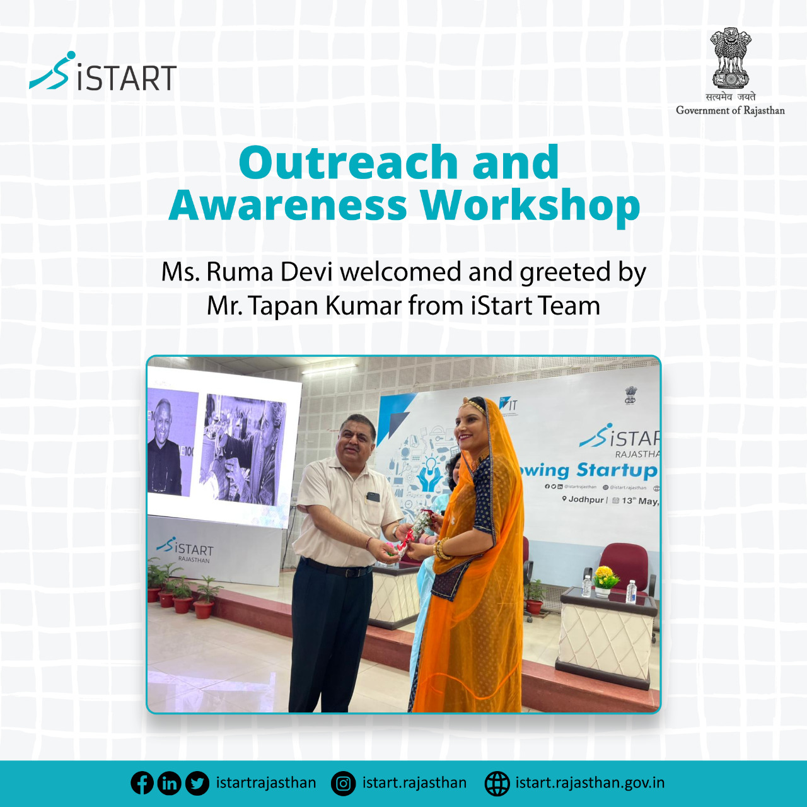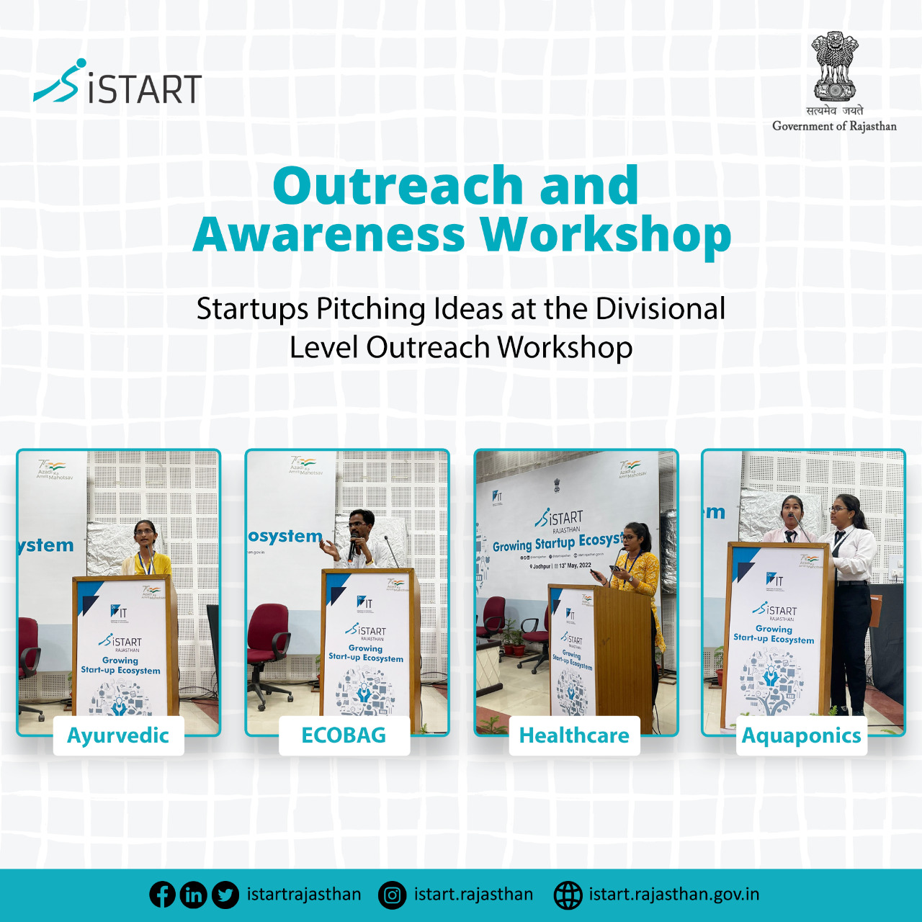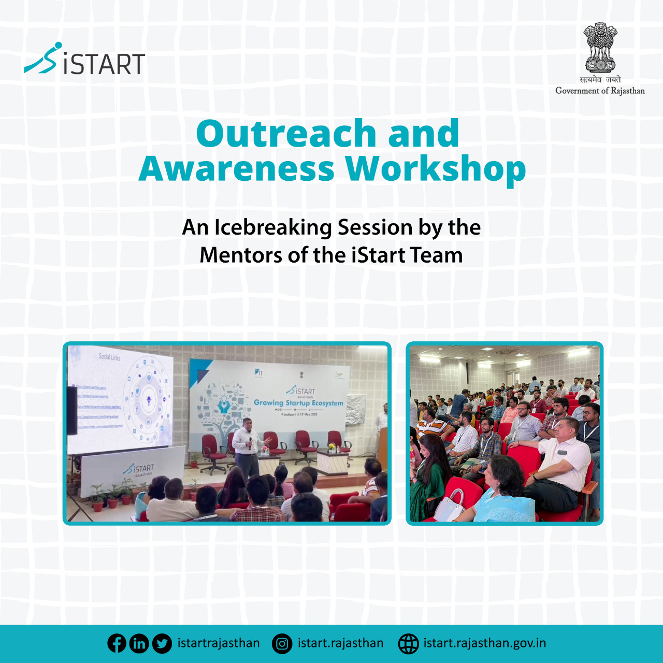

|  |
| --- |
| **Press Coverage** |
| 6.1 Prasann times, 13th  May 2022    6.2 Rajasthan Patrika, 13th May 2022        6.3 Rajasthan Patrika, 13th May 2022 |

|  |  |  |  |  |
| --- | --- | --- | --- | --- |
| **Participants** | | | | |
| **Sr. No.** | **Name** | **School/ College** | **Mobile No.** | **Email ID** |
| 1 | Suman bano | Govt.collage rahat pali | 6375627772 | [sumansodha2412@gmail.com](mailto:sumansodha2412@gmail.com) |
| 2 | Tanisheka tailor | Kankuvijay collage pali | 9358601817 | [tanishekatailor@gmail.com](mailto:tanishekatailor@gmail.com) |
| 3 | Palak sulani | Kankuvijay collage pali | 9509225999 | [palak.sulani@gmail.com](mailto:palak.sulani@gmail.com) |
| 4 | Dhrmesh ujjwal | Govt.collage rahat pali | 9636678101 | [deesooin@gmai.com](mailto:deesooin@gmai.com) |
| 5 | Deepshikha | Kankuvijay collage pali | 9119378992 | [charukanwrsbhati@gmail.com](mailto:charukanwrsbhati@gmail.com) |
| 6 | Rashmi purohit | Kankuvijay collage pali | 8209274042 | [rashnipurohit730@gmail.com](mailto:rashnipurohit730@gmail.com) |
| 7 | Komal | Kankuvijay collage pali | 8290380035 | [komalpatneeha@gmail.com](mailto:komalpatneeha@gmail.com) |
| 8 | Sharukh khan | Govt.collage rahat pali | 9784910050 | [sharukhkham96@gmail.com](mailto:sharukhkham96@gmail.com) |
| 9 | Urmila kandara | Govt.collage rahat pali | 830295805 | [urmilkandara8@gmail.com](mailto:urmilkandara8@gmail.com) |
| 10 | Rameshwar rathore | Govt.collage jodhpur | 8529145066 |  |
| 11 | Divanshu solanki | Govt.collage jodhpur | 9462354515 |  |
| 12 | Chandrika tiwari | Dms | 7023360699 | [tiwarichandrika@gmail.com](mailto:tiwarichandrika@gmail.com) |
| 13 | Arzu saran | Dms | 9024684012 | [choudharyarju18@gmail.com](mailto:choudharyarju18@gmail.com) |
| 14 | Deepashi ramawat | Dms | 9549144577 |  |
| 15 | Amit mathur | Dms | 6350411978 |  |
| 16 | Mohit choudhary | Jnvu | 8963800112 | [mohit.choudhary8963@gmail.com](mailto:mohit.choudhary8963@gmail.com) |
| 17 | Sandeep choudhary | Jnvu | 8290642517 | [sandeep1998jwala@gmail.com](mailto:sandeep1998jwala@gmail.com) |
| 18 | Chandra | Jnvu | 9784656660 | [chandra1863@gmai.com](mailto:chandra1863@gmai.com) |
| 19 | Nitish | Dms | 7023556526 | [nitishdholiya17@gmail.com](mailto:nitishdholiya17@gmail.com) |
| 20 | Chandraparaksh | Sbk gov. Collage jaisalmer | 8905446361 | [chandraprakash6361@gmail.com](mailto:chandraprakash6361@gmail.com) |
| 21 | Shivdan | Sbk gov. Collage jaisalmer | 8955798449 | [shivdan141102@gmail.com](mailto:shivdan141102@gmail.com) |
| 22 | Lakhan | Sbk gov. Collage jaisalmer | 9664126545 | [lakhanam9444@gmail.com](mailto:lakhanam9444@gmail.com) |
| 23 | Ramesh | Sbk gov. Collage jaisalmer | 9529053037 | [rathors16@gmail.com](mailto:rathors16@gmail.com) |
| 24 | Dwarka | Sbk gov. Collage jaisalmer | 7727091665 |  |
| 25 | Doulat panwar | Sbk gov. Collage jaisalmer | 9588044361 | [doulatpanwar@gmail.com](mailto:doulatpanwar@gmail.com) |
| 26 | Rohit bhati | Dms | 8824005831 | [rohitbhati9460@gmail.com](mailto:rohitbhati9460@gmail.com) |
| 27 | Prema ram | Sbk gov. Collage jaisalmer | 6367697607 |  |
| 28 | Pawan gupta | Krishna home health care | 8955210390 | [pg.3154162@gmail.com](mailto:pg.3154162@gmail.com) |
| 29 | Mumal parmar | Mahila pg | 9511512711 | [mumalparmar@gmail.com](mailto:mumalparmar@gmail.com) |
| 30 | Kunal kashyap | Bangur collage pali | 8824873049 | [kkashyap8209@gmail.com](mailto:kkashyap8209@gmail.com) |
| 31 | Naveen panwar | Bangur collage pali | 6376467758 | [naveenpanwar458@gmail.com](mailto:naveenpanwar458@gmail.com) |
| 32 | Mo. Kaif | Bangur collage pali | 9352346744 | [kaifgouri72@gmail.com](mailto:kaifgouri72@gmail.com) |
| 33 | Yuvraj prajapati | Bangur collage pali | 7877081646 | [yuvrajprajapat2003@gmail.com](mailto:yuvrajprajapat2003@gmail.com) |
| 34 | Aditya singh | Bangur collage pali | 7073954653 | [aditya44186@gmail.com](mailto:aditya44186@gmail.com) |
| 35 | Himanshu mali | Bangur collage pali | 8955952554 | [himanshumali076@gmai.com](mailto:himanshumali076@gmai.com) |
| 36 | Renuka chouhan | Kankuvijay collage pali | 9785686026 | [renukasinghchouhan31@gmail.com](mailto:renukasinghchouhan31@gmail.com) |
| 37 | Praksh | Sajjan internationl collage | 9571037789 | [prakashrathore409@gmail.com](mailto:prakashrathore409@gmail.com) |
| 38 | Lokendra singh | University birminghom | 9929587770 | [lsranod12@gmail.com](mailto:lsranod12@gmail.com) |
| 39 | Pushpendra singh | University birminghom | 9358787770 | [psronad444@gmail.com](mailto:psronad444@gmail.com) |
| 40 | Hansa rathore | K.n collage | 9982454738 | [hansarathore407@gmail.com](mailto:hansarathore407@gmail.com) |
| 41 | Ravindra singh dohiya | Jnvu | 8302060033 | [ravindhaiya243@gmail.com](mailto:ravindhaiya243@gmail.com) |
| 42 | Gourav panwar | Jnvu | 7793822528 |  |
| 43 | Anjali jain | Ldps collage jodhpur | 9509776848 | [anjalijain102001@gmail.com](mailto:anjalijain102001@gmail.com) |
| 44 | Rohit mawar | Jnvu | 7014139600 |  |
| 45 | Monu mawar | Jnvu | 9828327421 |  |
| 46 | Lalit | Jnvu | 9079106374 |  |
| 47 | Hitesh | New jnvu | 8302465867 |  |

|  |  |  |  |  |
| --- | --- | --- | --- | --- |
| **Officials** | | | | |
| **Sr. No.** | **Name** | **Department** | **Mobile No.** | **Email ID** |
| 1 | Dr. Kanraj pooniya | Govt. Collage barmer | 9414900015 | [kanpooniya@gmail.com](mailto:kanpooniya@gmail.com) |
| 2 | Dr. C.p gharu | Govt. Collage barmer | 9602286948 |  |
| 3 | Dr. Ss meena | Govt. Collage jaisalmer | 9414328596 | [ssmeena001@gmail.com](mailto:ssmeena001@gmail.com) |
| 4 | Manoj kumar soni | Krishna home helth care | 7357878999 | [manojsoni2014.ms@gmail.com](mailto:manojsoni2014.ms@gmail.com) |
| 5 | Vinay wlliams | Startups | 9660061777 | [wlliams.vinay@gmail.com](mailto:wlliams.vinay@gmail.com) |
| 6 | Sumit laddha | Knowledge wall | 8829029999 | [simitladdha001@gmail.com](mailto:simitladdha001@gmail.com) |
| 7 | Dhruv gour | Shri raj govind | 8233935776 | [mrdhruvgour@gmail.com](mailto:mrdhruvgour@gmail.com) |
| 8 | Shyam lal Aanwar | Devot motors | 9828033917 | [shyampanwar@gmail.com](mailto:shyampanwar@gmail.com) |
| 9 | Anand singania | Mbm engineering | 7014524491 | [theamand333@gmail.com](mailto:theamand333@gmail.com) |
| 10 | Prince jatoliya | Mbm engineering | 7427004434 | [rj170898@gmail.com](mailto:rj170898@gmail.com) |
| 11 | Deepak charan | Charantotal lab | 9799716055 | [charandeepak@gmai.com](mailto:charandeepak@gmai.com) |
| 12 | Dinesh shivani | India tools | 9414127444 | [dineshshivani@gmail.com](mailto:dineshshivani@gmail.com) |
| 13 | Dr. Shailendra gehlot | Govt. Collage jodhpur | 9828229912 | [gehllot_shail@yahoo.com](mailto:gehllot_shail@yahoo.com) |
| 14 | Dr. Hari ram parihar | Govt. Collage jodhpur | 9829181647 | [drparihar79@gmail.com](mailto:drparihar79@gmail.com) |
| 15 | Mohammed rafiq | Tripperbook pvt.ltd. | 9024030303 | [mrafiq@tripperbook.com](mailto:mrafiq@tripperbook.com) |
| 16 | Vikram pancharya | Agrom of pvt.ltd. | 9001388751 | [vikrampancharya35@gmail.com](mailto:vikrampancharya35@gmail.com) |
| 17 | Lalit kumar jain | Startups | 9214421000 | [lalit21000@gmail.com](mailto:lalit21000@gmail.com) |
| 18 | Vinod kumar jain | Startups | 9351305253 | [jainvinodchopala@gmail.com](mailto:jainvinodchopala@gmail.com) |
| 19 | Nihal gehst | Startups | 8387957000 |  |
| 20 | Amrit lal | Startups | 8764197899 | [amritlalap22@gmail.com](mailto:amritlalap22@gmail.com) |
| 21 | Dr. Ram saini | Gbdc collage | 8003689788 | [dr.ram.akela@gmail.com](mailto:dr.ram.akela@gmail.com) |
| 22 | Devendra singh rathore | Sarthi health care pvt.ltd | 9314710655 | [care@sarthihealthcare.com](mailto:care@sarthihealthcare.com) |
| 23 | Sudhanshu tank | Cnp pvt.ltd. | 9828032289 | [suudhanshutak@rediffmail.com](mailto:suudhanshutak@rediffmail.com) |
| 24 | Anil choudhary | Imd | 7976116811 | [anil.choudhary03@gmail.com](mailto:anil.choudhary03@gmail.com) |
| 25 | Mahendra singh bhati | Doit | 7737629678 |  |
| 26 | Amit purohit | Doit | 9983141398 |  |
| 27 | Shaheen pravex | Doit | 7737919110 |  |
| 28 | Vikram choudhary | Doit | 9024342628 |  |
| 29 | Ashok vishnoi | Doit | 9461329029 |  |
| 30 | Anil singh | Atal incubation center bimtech | 9599836232 | [anil.singh@aichimtech.com](mailto:anil.singh@aichimtech.com) |
| 31 | Kuldeep | Doit | 9413661811 |  |
| 32 | Raghav sharma | Mbm.e.c. | 7627070661 |  |
| 33 | Divya multani | Marwari catalyst | 9672224441 |  |
| 34 | Anshu jain | Year book canwas | 9672224441 |  |
| 35 | Devendra gehlot | Doit | 9413249802 |  |
| 36 | Jitendra | Punjab kesri | 9636222286 |  |
| 37 | Yashpal singh | 24 news | 9928324422 |  |
| 38 | Dr swapne pelru | Dms jnvu | 9414133489 |  |
| 39 | Pawan chopu | Startups | 9414498356 |  |
| 40 | Aehloram pharwar | Mm jodhpur | 9461221991 |  |
| 41 | Gautam goyal | Doit | 9529060041 |  |
| 42 | Rajesh | It | 9785869100 |  |
| 43 | Twinkle kalle | Startups | 9680792574 |  |
| 44 | Manish bhati | Doit | 9413958997 |  |
| 45 | Paray kachawah | Doit | 9694376878 |  |
| 46 | Mr. Pourohit | Doit | 9414914079 |  |
| 47 | Ashutosh vyas | Doit | 9414916986 |  |
| 48 | Faaezes | First track coffee | 9829881929 |  |
| 49 | Lokendra singh | Vidhishree venture | 7300190111 |  |
| 50 | Amit mathur |  |  |  |
| 51 | Sumit deora | Dd news | 9950280699 |  |
| 52 | Siddharth tatiya | Mohisha venture | 9828370071 |  |
| 53 | Mahaveer prewa | Startups | 9462413121 |  |
| 54 | Manoj gehlot | Doit | 9413277772 |  |
| 55 | Laksh vashnav | Doit | 7976883130 |  |
| 56 | Prof. Manoj choudhary | Iit jodhpur | 9845541701 |  |
| 57 | Shreyansh tatiya | Startups | 9555390991 |  |
| 58 | Naveen kaushik | Dm (nulm) nagar nigam jodhpur | 7791901660 |  |
| 59 | Sharwan ji |  |  |  |
| 60 | Khemendra ji |  |  |  |
| 61 | Rakesh sharma |  |  |  |
| 62 | Sandeep parihr | Startups | 9910223580 |  |
| 63 | Harshit soni | Startups | 9116852018 |  |
| 64 | Jatin saini | Startups | 9116852018 |  |
| 65 | Lokesh jangid | Startups | 9116852018 |  |
| 66 | Dr. Apurva mathur | Asst. Prof. Cbc pali | 9214421883 |  |
| 67 | Dr. Vinita arora | Asst. Prof.cbc pali | 8949507202 |  |
| 68 | Devoshish panwar | Startups | 7665430917 |  |
| 69 | Navratan soni | Software it | 9414610180 |  |
| 70 | Anuj khandelwal | Startups | 7597523702 |  |
| 71 | Rameshwar gehlot | Doit | 9929653166 |  |
| 72 | Sabar bharti | Aovocatk & attorney | 9983344535 |  |
| 73 | Rahul panwar | Startups | 9660233818 |  |
| 74 | Pradeep | Doit | 9929827573 |  |
| 75 | Arun | Doit | 9414916708 |  |
| 76 | Harsh | Doit | 9413319651 |  |
| 77 | Swapnil garg | Doit | 9530498895 |  |
| 78 | Chirag gupta | Doit | 7737778480 |  |
| 79 | Dr. G.v. Mishra | Collage education sirohi | 9414475718 |  |
| 80 | Praduyaman dev jodha | Shri bhadrajun ovt. Ltd | 9321852686 |  |
| 81 | Raju lilawat | Doit | 9950472271 | [raju295lilawat@gmail.com](mailto:raju295lilawat@gmail.com) |
| 82 | Kapil lama | Doit | 9828500286 |  |
| 83 | Togram | Handicraft india | 9251608597 |  |
| 84 | Akash choudhary | Kyndl solucation pvt. Ltd | 9990811186 |  |
| 85 | Dilip kumar | Proff. Govt. Collage barmer | 8005509359 | [dilipparmar21031975@gmail.com](mailto:dilipparmar21031975@gmail.com) |
| 86 | Mahnor | Drigo | 9214290029 |  |
| 87 | Vaibhav | Metergg pvt. Ltd. | 8209878974 |  |
| 88 | Vishnu choudhary | Dr. Site | 9460683280 | [vishnu.doit@rajasthan.go.in](mailto:vishnu.doit@rajasthan.go.in) |
| 89 | Anil sharma | Dr. Site | 7740895508 |  |
| 90 | Mahesh gupta | Dr. Site | 9636277376 |  |
| 91 | Suresh kumar | Dr. Site | 7742445510 |  |
| 92 | Surendra kataria | Doitc | 8619468573 |  |
| 93 | Nikhilesh | Doitc | 8000195439 |  |
| 94 | Kapil agarwal | Atal incubation center bimtech | 8585727623 | [kapil.agaewal@aicbimtech.com](mailto:kapil.agaewal@aicbimtech.com) |
| 95 | Vijay | Doitc | 9784045393 |  |
| 96 | Anil rawal | Doitc | 9462052851 |  |
| 97 | Inder | Doitc | 9529227453 |  |
| 98 | Prashant jorwal | Doitc | 9928671587 |  |
| 99 | Dhirendra singh | Doitc | 9983974797 |  |
| 100 | Hatiom bishnoi | Doitc | 8233041934 |  |
| 101 | Collector jodhpur |  |  |  |
| 102 | Councler tda |  |  |  |
| 103 | V.c. Jnvu |  |  |  |
| 104 | Dr. Iitj |  |  |  |
| 105 | Dr. Aiims jodhpur |  |  |  |

|  |  |  |  |  |
| --- | --- | --- | --- | --- |
| **Self Help Group (S.H.G)** | | | | |
| **Sr. No.** | **Name** | **Department** | **Mobile No.** | **Email ID** |
| 1 | Kanchan | Baba sahab swyam sahayata samuh | 9166153122 |  |
| 2 | Bhagwati | Baba sahab swyam sahayata samuh | 7610847534 |  |
| 3 | Rukmani | Baba sahab swyam sahayata samuh | 9799548638 |  |
| 4 | Prem | Baba sahab swyam sahayata samuh | 9636913725 |  |
| 5 | Kavita | Baba sahab swyam sahayata samuh | 9667835459 |  |
| 6 | Suman | Baba sahab swyam sahayata samuh | 7568891074 |  |
| 7 | Kunni devi | Baba sahab swyam sahayata samuh | 8890162297 |  |
| 8 | Guddi | Baba sahab swyam sahayata samuh | 9414124953 |  |
| 9 | Indra | Baba sahab swyam sahayata samuh | 9799855908 |  |
| 10 | Sangeeta | Baba sahab swyam sahayata samuh | 7357941543 |  |
| 11 | Hemlata | Ridhi swyam sahayata samuh | 7976430429 |  |
| 12 | Bhawati devi | Ridhi swyam sahayata samuh | 8107064704 |  |
| 13 | Chukki | Ridhi swyam sahayata samuh | 9001973605 |  |
| 14 | Sangeeta | Ridhi swyam sahayata samuh | 6377742745 |  |
| 15 | Salma | Hajra mela | 9509152424 |  |
| 16 | Nargis | Hajra mela | 9509152424 |  |
| 17 | Nafisa | Ladli group | 6350198393 |  |
| 18 | Shahnaz bano | Goshiya swyam sahayata samuh | 6375213646 |  |
| 19 | Chanda bano | Goshiya swyam sahayata samuh | 6350388274 |  |
| 20 | Rukshana bano | Goshiya swyam sahayata samuh | 6375741876 |  |
| 21 | Rekha | Sonpari group | 8279271144 |  |
| 22 | Sapna | Sonpari group | 7976498700 |  |
| 23 | Ankita | Sonpari group | 9571158680 |  |
| 24 | Santosh | Sonpari group | 9351754543 |  |
| 25 | Nitu | Sonpari group | 8955224744 |  |
| 26 | Gavari chouhan | Ridhi swyam sahayata samuh | 7877347708 |  |
| 27 | Suman | Sidhi swyam sahayata samuh | 7877796984 |  |
| 28 | Sarswati | Sidhi swyam sahayata samuh | 7877728488 |  |
| 29 | Divya | Sidhi swyam sahayata samuh | 7877728488 |  |
| 30 | Vanita | Sidhi swyam sahayata samuh | 9001734286 |  |
| 31 | Hemlata | Ridhi swyam sahayata samuh | 8824172247 |  |
| 32 | Sushila | Sain ji maharaj samuh | 8829939056 |  |
| 33 | Annu devi | Tamki maharaj samuh | 9829675629 |  |
| 34 | Saroj | Tamki maharaj samuh | 9358953432 |  |
| 35 | Pooja | Tamki maharaj samuh | 8890633950 |  |
| 36 | Tamki | Tamki maharaj samuh | 9829675629 |  |
| 37 | Tara | Tamki maharaj samuh | 8690654369 |  |
| 38 | Pintu | Tamki maharaj samuh | 7357029950 |  |
| 39 | Jayda | Barkat swyam sahayata samuh | 6375877664 |  |
| 40 | Reshma | Barkat swyam sahayata samuh | 6367331956 |  |
| 41 | Samsad | Barkat swyam sahayata samuh | 9588904950 |  |
| 42 | Israt | Barkat swyam sahayata samuh | 9887116516 |  |
| 43 | Sajjo | Barkat swyam sahayata samuh | 9829288300 |  |
| 44 | Rukma devi | Saya mahila | 8502932774 |  |
| 45 | Koshlya devi | Saya mahila | 9829097502 |  |
| 46 | Shakuntla | Saya mahila | 8502932774 |  |
| 47 | Kunti devi | Saya mahila | 8502932774 |  |
| 48 | Nagma | Barkat swyam sahayata samuh | 6375877664 |  |
| 49 | Sayaro bano | Barkat swyam sahayata samuh | 9829288300 |  |
| 50 | Pushpa | Bajrang group | 9145804507 |  |
| 51 | Urmila | Bajrang group | 9166676512 |  |
| 52 | Sumitra | Bajrang group | 9145804507 |  |
| 53 | Laxmi | Bajrang group | 9782381725 |  |
| 54 | Maina | Bajrang group | 8696168008 |  |
| 55 | Anita | Bajrang group | 8696168008 |  |
| 56 | Aarti | Jai mata di group | 7014166226 |  |
| 57 | Firdous | Sonpari aadash group | 9252112345 |  |
| 58 | Santosh vaishnav | Sonpari aadash group | 7976541916 |  |
| 59 | Uma vaishnav | Sonpari aadash group | 9782587926 |  |
| 60 | Farjana | Sonpari aadash group | 7062519777 |  |
| 61 | Shushila vaishnav | Sonpari aadash group | 8559835664 |  |
| 62 | Sumitra devi | Sonpari aadash group | 6367380607 |  |
| 63 | Roshan banu | Sonpari samrin group | 9511597499 |  |
| 64 | Pimky banu | Sonpari samrin group | 7023955222 |  |
| 65 | Nagma banu | Sonpari samrin group | 7221984386 |  |
| 66 | Simran bani | Sonpari samrin group | 9511597499 |  |
| 67 | Kanchan | Jai shree krishna group | 9145804511 |  |
| 68 | Jaishree | Jai shree krishna group | 8302685347 |  |
| 69 | Madhulata | Jai shree krishna group | 9829920516 |  |
| 70 | Lalita | Jai shree krishna group | 800985632 |  |
| 71 | Manju naval | Jai shree krishna group | 7073351601 |  |
| 72 | Kanta | Jai shree ganesh group | 8238788684 |  |
| 73 | Dhaneshwari | Jai shree ganesh group | 9664207670 |  |
| 74 | Sapna naval | Jai shree ganesh group | 8302210080 |  |
| 75 | Manju | Jai shree ganesh group | 9352664058 |  |
| 76 | Rekha | Jai shree ganesh group | 6377589463 |  |
| 77 | Aruma | Mahadev s.h.g. | 8005727576 |  |
| 78 | Premlata | Dariya s.h.g. | 9672462376 |  |
| 79 | Kavita | Jai nari group | 9772823746 |  |
| 80 | Yogita | Jai nari group | 8619300525 |  |
| 81 | Sunita | Jai nari group | 8619300525 |  |
| 82 | Twinkle vaishnav | Jai nari group | 8619300525 |  |
| 83 | Kiran | Radhe-radhe group | 8947085986 |  |
| 84 | Hansha | Radhe-radhe group | 8104446610 |  |
| 85 | Manju | Radhe-radhe group | 8005535855 |  |
| 86 | Pramila | Radhe-radhe group | 8209214901 |  |
| 87 | Vimla | Radhe-radhe group | 7426841211 |  |
| 88 | Pooja | Surya nagri | 8160932172 |  |
| 89 | Jaishree | Surya nagri | 7073654210 |  |
| 90 | Dheli devi | Samarthig shg | 7023580869 |  |
| 91 | Guddi devi | Jeta shg | 9116828979 |  |
| 92 | Suraj devi | Jeta shg | 7877064638 |  |
| 93 | Kavita | Nurani shg | 8094172640 |  |
| 94 | Premi | Santoshi shg | 8003363424 |  |
| 95 | Seeta devi | Khemaj shg | 7791816764 |  |
| 96 | Jamuna devi | Vjash shg | 9986306458 |  |
| 97 | Imdad ji | Nngm rohidi | 9799446987 |  |
| 98 | Santosh | Ashapuri maa | 8107820871 |  |
| 99 | Gajri devi | Ekta group | 8107975591 |  |
| 100 | Meena | Maira group | 7878206547 |  |
| 101 | Seema | Maira group | 9610190591 |  |
| 102 | Durga | Maira group | 7073294097 |  |
| 103 | Sonu | Mahila shakti | 8769294161 |  |
| 104 | Lakshmi | Mahila shakti | 7742623192 |  |
| 105 | Manju | Mahila shakti | 8094382955 |  |
| 106 | Sunita | Mahila shakti | 8290890960 |  |
| 107 | Gisu devi | Mahila shakti | 8769294161 |  |
| 108 | Suman sharma | Mahila shakti | 8769294161 |  |
| 109 | Ravina | Mahila shakti |  |  |
| 110 | Manbhar devi | Mahila shakti | 8769294161 |  |