Name of the Event | Rajasthan Drone Expo 2022
Date(s) | 16th June 2022
Time | 09:30 AM – 05:00 PM
Venue | Techno Hub, Jaipur
Agenda | To spread awareness and promote drone technology among Rajasthan government’s various departments by Drone OEM/ Startup/Distributor /service provider etc.
Brief Description of the Event
Background

The state govt plans to buy 1,000 drones for various departments, as the newspaper headline gives complete insights into how drone tech will play a key role in industry and people's life.

In budget 2022, Honorable chief minister Shri Ashok Gahlot announced that the Government of Rajasthan would purchase the 1000 drones for various departments in the state.

To promote the drone tech Government of Rajasthan and Department of Information Technology & Communication (DoIT&C) organized the Rajasthan Drone Expo 2022 at Techno Hub, Jaipur. More than 50 drone manufacturers demonstrated & discuss the capabilities of their drones with the Government of Rajasthan officials, the iStart team, and all the exhibition attendees. Drone manufacturers' company representatives explain why drone tech is essential for people.

Here are the some of the capabilities of drones
- The drones can save lives in floods and underwater emergencies and can be used as an asset in flood-affected areas.
- Drones have also demonstrated the potential to aid in agriculture.

Shri Akhil Arora, Principal Secretary, Department of Information Technology and Communications, visited the drone exhibition and discussed in detail with the drone manufacturers about its use. He instructed the departmental officers to ensure the use of drones.

Earlier, Commissioner Shri Sandesh Nayak opened the program and shared his views with those present. Underlining the importance of drone technology to farmers, Shri Nayak said that drones could help farmers not only with irrigation and pesticide spraying but also in investigating the damage and losses caused by adverse weather and conditions. Drones can help police, water, wildlife, and other departments with surveillance and security. He said the day is not far away when drones will be available for home deliveries.

Rajasthan is the first state department to cooperate and Propose MoUs with NITI Aayog, HDFC Bank, PHD Chambers of Commerce and FICCI FLO, ICICI Bank, Amazon (AWS) to expand the startup ecosystem in the state. Anna Roy, the senior advisor to NITI Aayog, said Rajasthan is the first state to partner with the NITI Aayog Women Entrepreneurship Program (WEP), which will encourage state women entrepreneurs and take advantage of the many facilities provided by the government.

Mr. Pradeep Namdev and Mr. Pranav Raut, M/s Prakhar Software Solutions Pvt. Ltd., discuss with Government of Rajasthan officials and iStart Team and other attendees about ‘the drone laws in India’ while Mr. Amrit Mohapatra shared information on ‘Types of drones based on technology and usage’ at Auditorium.

With the drone product showcase and demonstration by invited OEMs and attendees see the live demonstration of the capacities of drones.

The government of Rajasthan’s various departments Agriculture, Forest Department, Police Department, RSLDC, Home Department, etc. showed interest in this drone expo 2022.

Government of India officials from NITI Ayog also attended this drone expo and gave meaningful insights and appreciated the effort by the Government of Rajasthan department (DoIT & C) and iStart team to promote drone tech and spread the awareness of this futuristic tech.

Picture from the Event
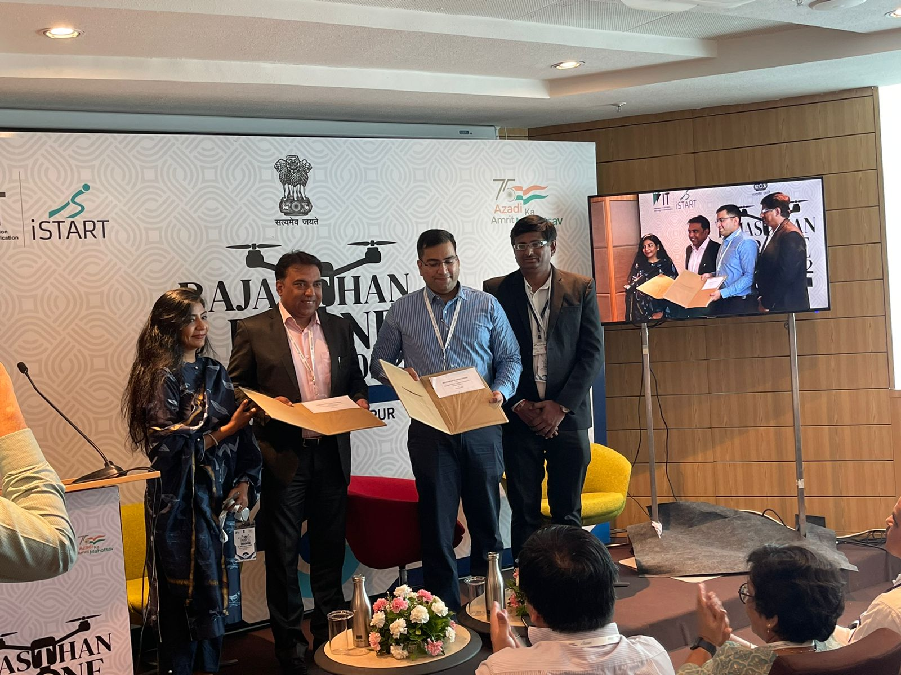
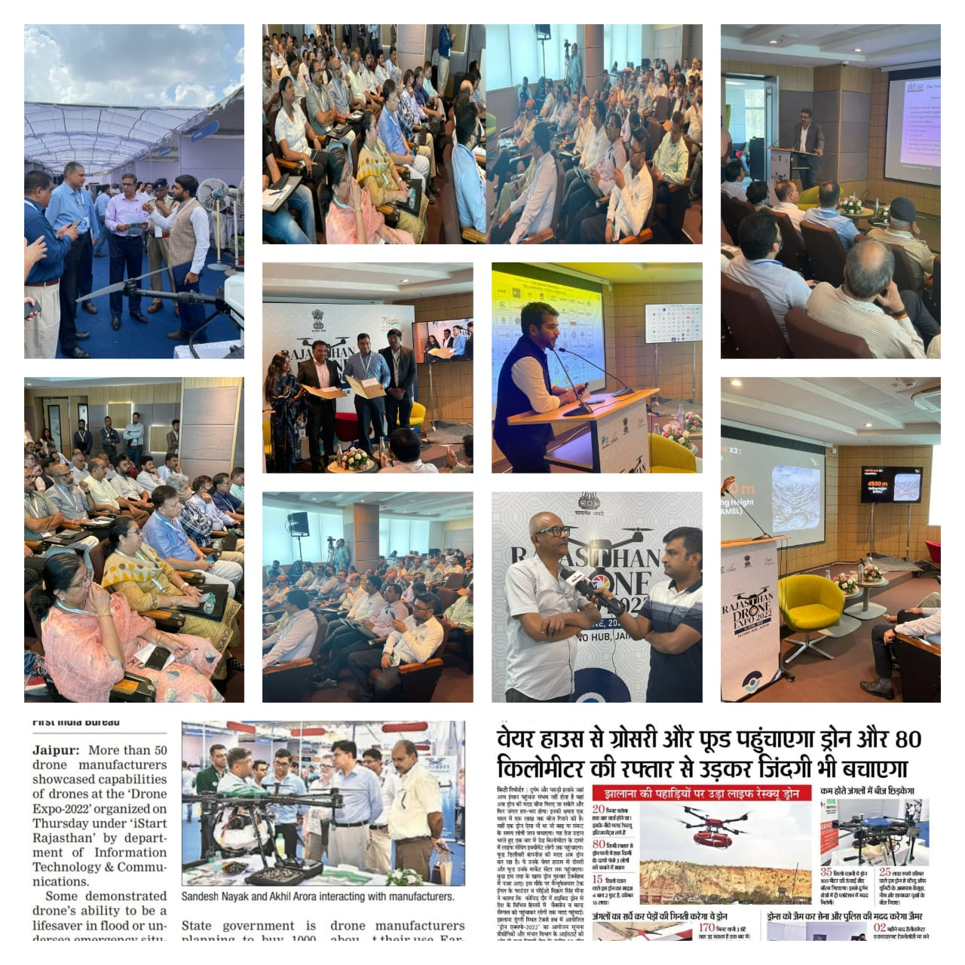

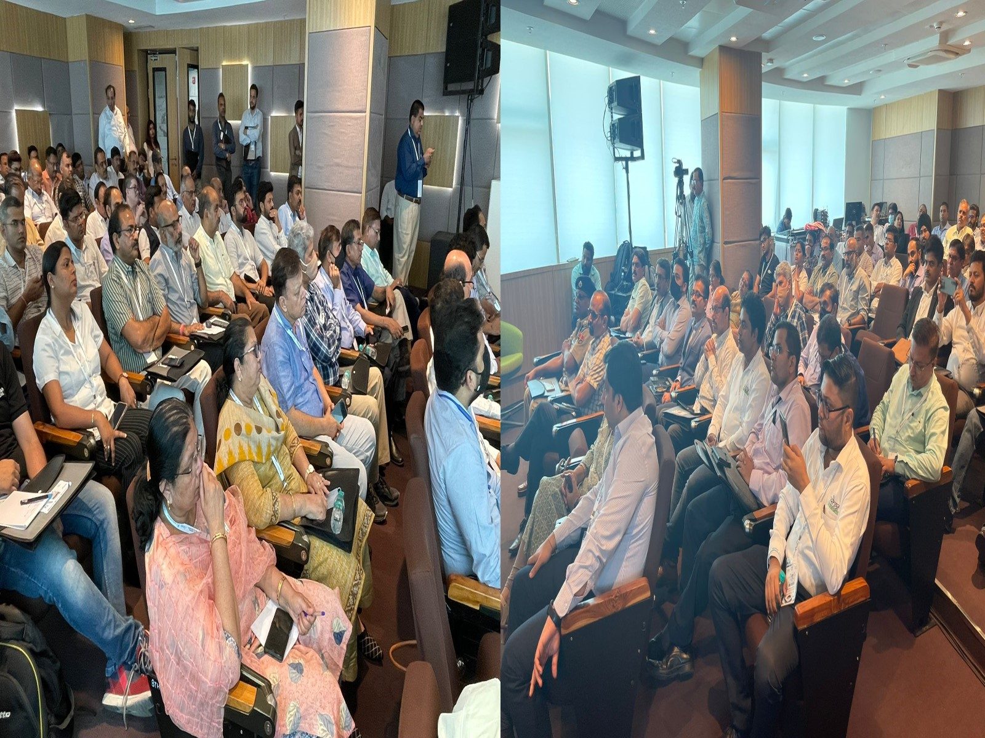
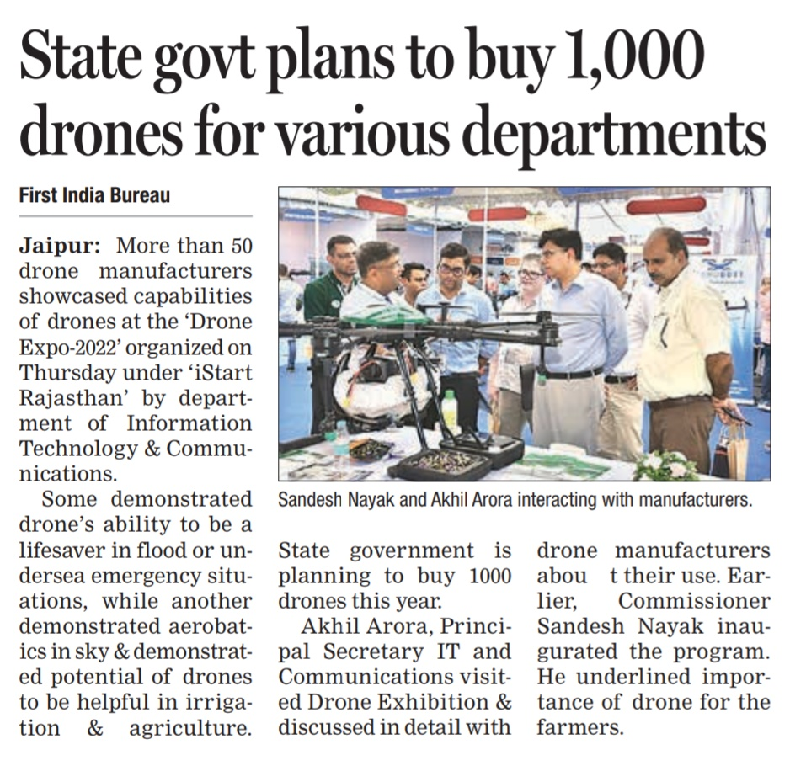

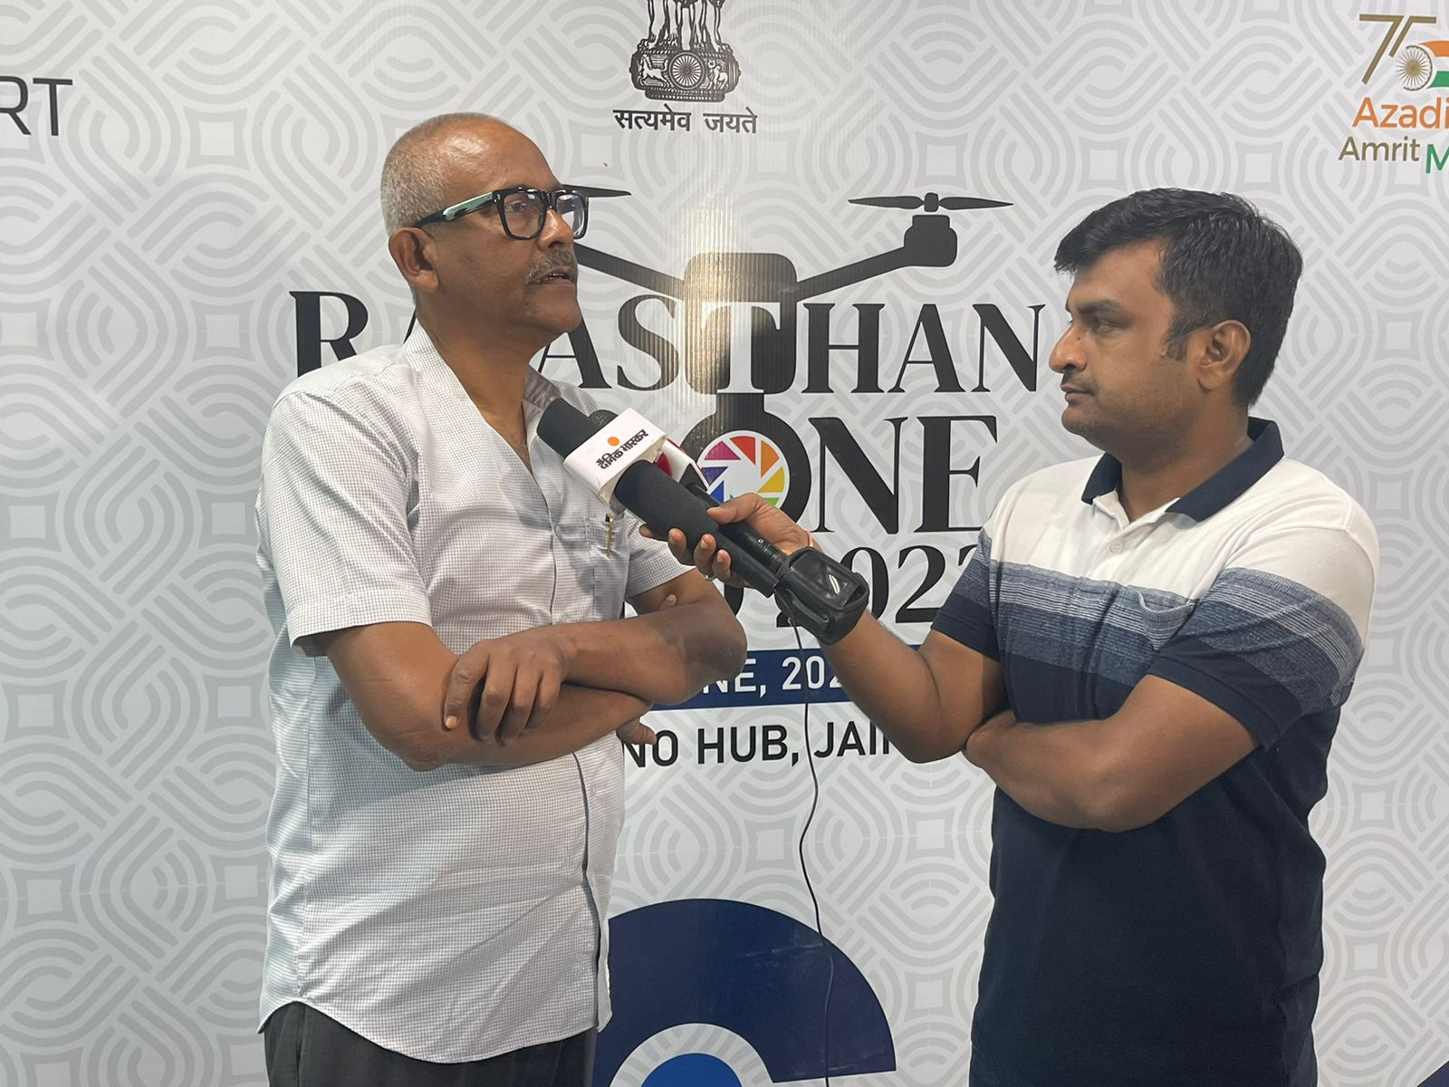
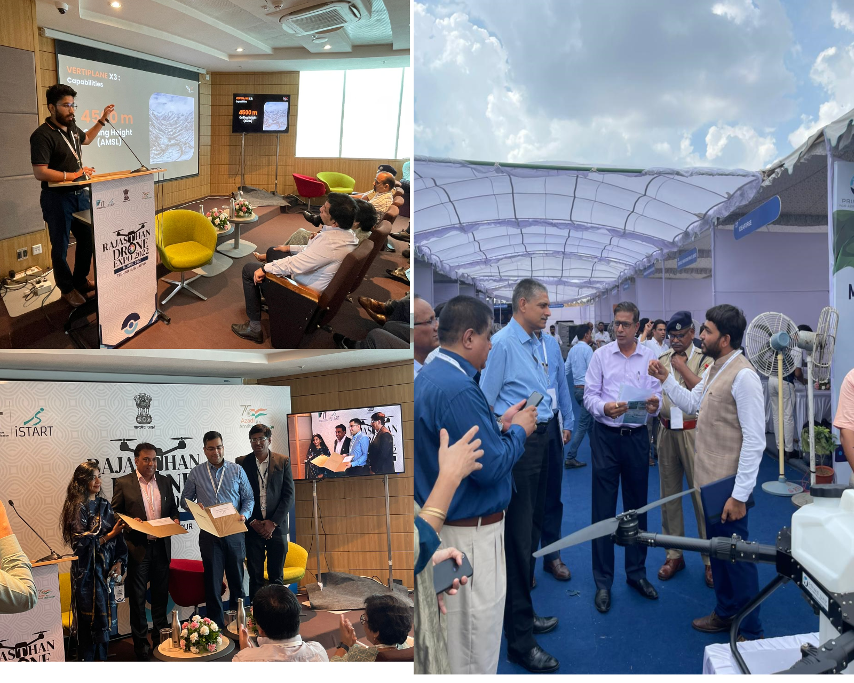

DRONE VENDORS LIST
S.No | Company Name | Website | Representative Name | Mobile | Mail
1 | Hawking Defence  Services Pvt Ltd | www.hawkingdefence.com | Capt. Amber Singh | 9810219667 | ambersingh@hawkingdefence.com
2 | Garuda Aerospace Pvt Ltd | www.garudaaerospace.co m | Ashish Parashar and Raj Bhatia | 9899799007 | Ashish.parashar@garudaaerospace.com
3 | Techeagle Innovations  Private Limited | www.techeagle.in | Vikram Singh | 8173895211 | vikram@techeagle.in
4 | DCM Shriram Industries | www.dcmshriram.com | Mohd Altamash | 9540280320 | maltamash@dcmsr.com
5 | Defy Aerospace Pvt.  Ltd. | www.defyaerospace.com | Nehaal Agarwal | 9967789913 | samriddhipandey@defyaerospace.com
6 | Asteria Aerospace  Limited | asteria.co.in | Vivek Sharma | 9773621536 | johnson.toppo@asteria.co.in
7 | Drogo Drones | drogodrones.com | Rahul Pinnamaneni | 9885430567 | rahul@drogodrones.com
8 | Visron Pvt Ltd | Not Available | Vinay Kumar Yadav | 8112214315 | reso.vinay@gmail.com
9 | Wow Go Green Llp | Not Available | DR. SHANKAR GOENKA | 9811229551 | sg@shankargoenka.com
10 | Indowings Pvt Ltd | indowings.com | Sanjiv Budhraja | 9818747076 | admin@indowings.com
11 | Dronamaps Private  Limited | dronamaps.com | Poonam Gupta | 9313554043 | pgupta@dronamaps.com
12 | Prakhar Software Solutions Pvt. Ltd. | prakharsoftwares.com | Pradeep Namdeo | 8287600416 | pradeep.namdeo@prakha rsoftwares.com
13 | Sagar Defence  Engineering Pvt. Ltd. | www.sagardefence.com | Mridul Babbar | 9034966650 | mridulbabbar@sagardefence.com
14 | Aviakul Private Limited | www.aviakul.com | Vaibhav Varun | 9821219884 | vaibhav.varun@aviakul.co
15 | Pan India Consultants  Pvt Ltd | www.panindiagroup.com | KAILASH SINGH | 9953054858 | kailashsingh@panindiagroup.com
16 | Aerosys Aviation India Pvt. Ltd. | aerosysaviation.com | Avinash Kumar | 8210160548 | avinash@aerosysaviation. com
17 | Rajasthan Electronics & Instruments Limited, Jaipur | www.reiljp.com/index.asp x | Dr. P N Sharma ; Sandeep prem | 7727011718 | pn.sharma@reil.co.in ; sandeep.prem@reil.co.in
18 | Dronetech Solution Pvt  Ltd | Not Available | Arpana Mishra | 9820332793 | ceo@aerobott.com
19 | Abm Knowledgeweare  Limited | abmindia.com | Ravi Sharma | 9811768612 | ravi.sharma@abmindia.com
20 | Eagleeye Drones Pvt. Ltd. | eagleeyedrones.in | Sumogh GS | 9972323450 | gssumogh@eagleeyedrones.in
21 | Ideaforge | www.ideaforge.co.in | Anil Kumar Yadav | 9810085284 | anil.yadav@ideaforge.co.i  n
22 | Prime UAV | primeuav.com | Pradip Patel | 9979963653 | info@primeuav.com
23 | Theta Enerlytics Private  Limited | www.thetaenerlytics.com | KARAN DHAUL | 9811907214 | karandhaul@gmail.com
24 | Microlight Aviation  Private Limited | microlightaviation.in | Capt. Vibhuti Singh  Deora | 9828011166 | microlightaviation@gmail.  com
25 | Sparrow Bot | Not Available | Sunny Kumar | 9988782427 | Sparrowbot22@gmail.com
26 | Vimaana Aerospace  Technologies Llp | www.vimaanatech.com | Mridul Jain | 9899170989 | mridul.jain@vimaanatech.  com
27 | Kite Aero Pvt. Ltd. | Not Available | Capt. Virendra Panchal | 9228297777 | kiteaero@gmail.com
28 | Hind Innovations | Hindinnovation.com | Girish Soni | 9315007143 | hindinnovations@gmail.com
29 | Satonova Lifescience Pvt. Ltd. | Not Available | Akshay asopa | 8769769200 | asopaakshay@gmail.com
30 | Drone Destination  Private Limited | www.thedronedestination.com/ | Chirag Sharma, CEO | 9990060650 | chirag@thedronedestination.com
31 | Garud Survey Private Limited | www.garudsurvey.com | VISHAL MODI | 7733911999 | info@garudsurvey.com
32 | Dronelab Technologies  Pvt Ltd | www.dronelab.in | Nikhil Methiya | 9409415494 | Nikhil@dronelab.in
33 | Sudarshan Techno  Solution Pvt Ltd | Not Available | Arvind Kumar | 9805002123 | arvind@sudarshantechnosolution.com
34 | Sunft Pvt Ltd | Not Available | Apurva Jain | 8602583830 | apurva@sunft.in
35 | Indrone Aero Systems | indroneaerosys.com | Nikhil Pandey | 8277017503 | nikhil.p@indroneaerosys.c  om
36 | Zuppa Oeg Gen5  Technologies Private Limited | Not Available | ARVIND N. RAICHUR | 9731069111 | arvindraichur@zuppa.io
37 | Aviakul Pvt Ltd | Not Available | Shreyash Bhargava | 9079762716 | shreyash.bhargava@aviak  ul.com
38 | Hella Infratech Pvt Ltd | www.hellainfratech.com | Trupti Ramesh Dalvi | 9321435098 | trupti.dalvi@hellainfratech.com
39 | Eva Technologies | www.eva-technologies.co  m | NAGESHWAR SINGH | 8097821292 | nagesh@eva.xyz
40 | Elena Geo Systems  Private Limited | elenageosystems.com | Maj. Sushil Kumar  (Retd.) | 9810178958 | info@elenageosystems.co  m
41 | Esri India Technologies  Pvt Ltd | www.esri.in | Samkith Bagmar | 7892012383 | samkith.bagmar@esri.in
42 | Ayaan Autonomous System Pvt Ltd | ayaan.ai | Ritesh Yalkar | 9822397070 | ritesh.yalkar@ayaan.ai
43 | M S Enterptises | Not Available | Aditya agarwal | 9929900009 | aaditya.ag16@gmail.com
44 | Ordnance Equipment Factory Kanpur, Department Of Defence  Production | ddpdoo.gov.in/units/OEFC | Rakesh Gupta, Jr Works Manager (SG) | 9415406832 | sandeepchauhan0576@gmail.com
45 | Technit Space And Aero Works Private Limited | Not Available | Sudhanshu Mishra | 8826953100 | sudhanshu@tsaw.tech
46 | Airbots Aerospace Pvt  Ltd | Not Available | Danish ghori | 7738388848 | vishal@airbots.co.in

