Name of the Event | Workshop on Cyber Security: 2022
Date(s) | ^{14th} July 2022
Time | 09:30 AM – 05:00 PM
Venue | Techno Hub, Jaipur
Agenda | To spread awareness about Cyber Security.
Brief Description of the Event
The Department of Information Technology and Communications (DoIT&C) is aiming to boost emerging technologies and put them to best use throughout Government Departments & its parastatals to improve the administration of state programs and services. Towards this end, iStart Rajasthan which is the flagship scheme of the Government of Rajasthan under DoIT&C to promote entrepreneurship and innovation organized a workshop on cyber security on 14th July 2022 at Techno Hub, Jaipur. This workshop was meant to disseminate knowledge, create awareness and encourage candid discussions on cyber security.

The objective of conducting the workshop was fourfold. First, bring foremost cyber security experts in the field, startups in the domain, and government departments for a deep dive into this critical topic. Second, to create a joint platform for information exchange to ensure cyber security, operational efficiency, and chart future directions. Third, to share lessons learned and best practices from decades of hands-on experience defending (and infiltrating) some of the most secure networks and facilities. Four, to give the opportunity to startups in this domain a platform to pitch their product ideas.

Shri Ashish Gupta (IAS) Commissioner and Joint Secretary to Government – DoIT&C delivered key-note address on the topic and Shri Sharat Kaviraj, IPS IG, SCRB, Jaipur will grace the occasion as Chief Guest. Sessions will be on wide ranging topics from cyber threats and securities, financial frauds, and social media crimes, to game changing technologies in crime investigations. Towards the end, few startups in cyber security domain got the opportunity to showcase their products and services.

Picture from the Event
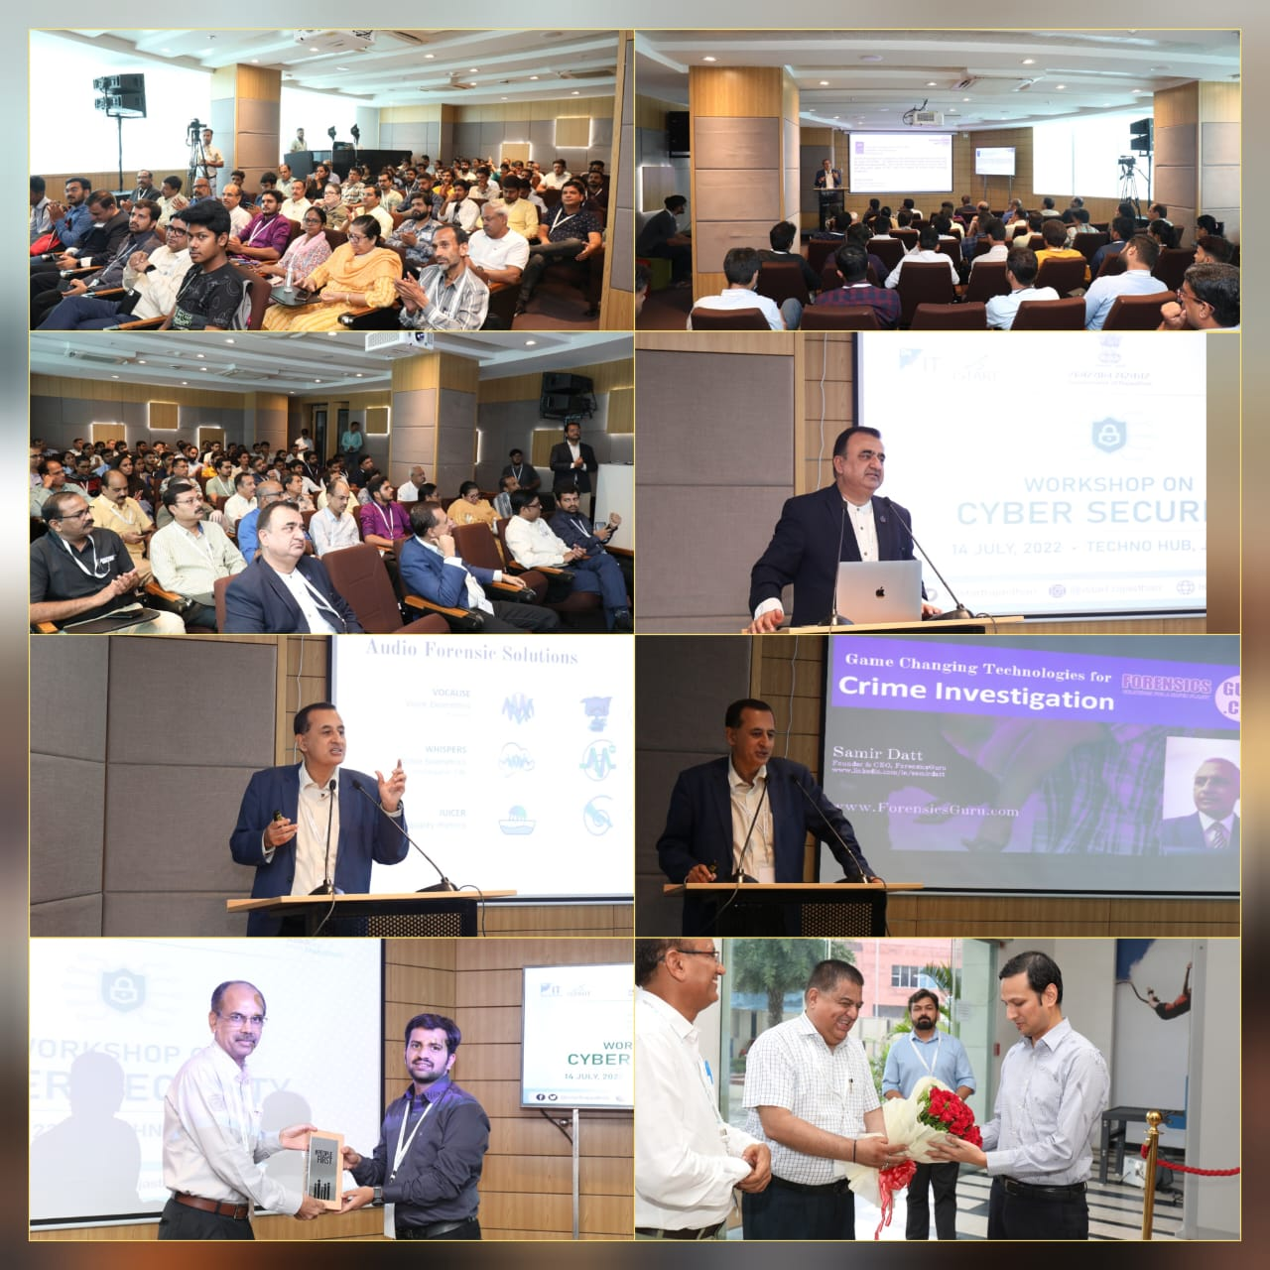

List of Startup Participated
Annexure A
S.no. | Startup Name |  | Representative Name | Mobile Number | Email
1 | Ram singh | Ram |  | 1234567890 | Manish
2 | Royalcraftsofindia | Deepraj |  | 8562020910 | Info@royalcraftsofindia.com
3 | Sago Men Power Private Limited | Sanjay Kumar Bhargav |  | 9950502961 | sanjaykumar221026@gmail.com
4 | SHOPSKY | SNEHA NATH |  | 7737145796 | loki89662@gmail.com
5 | IEZAL PRIVATE LIMITED | Manish Samota and Suresh Joshi |  | 9636234600 | manishsamota28@gmail.com
6 | Cybsoul Soft | Hemant vijay singh |  | 9214466001 | Cybsoul@gmail.com
7 | Qlicksy | Sidharth Kulshrestha |  | 9351480595 | Sidharthkulshreshtha@gmail.com
8 | Testntrack | Vinay Kamal Sharma & Priya Soni |  | 8949986554 | official.testntrack@gmail.com
9 | Verdant Impact | Manish kumar |  | 9672025828 | Manish@verdantimpact.com
10 | Shunya Gyaan | Mayank Sharma |  | 8302323372 | mayanksharma6861@gmail.com
11 | Accountax.online Pvt Ltd | Ghanshyam Agrawal |  | 9672234561 | info@accountax.in
12 | PROECART PRIVATE LIMITED | DHARMENDRA JANGID |  | 7597976767 | adi.s968@gmail.com
13 | Designeree | Aaditya sharma |  | 8003395224 | ar.aadityasharma@gmail.com
14 | Suvidha asset management | Ronak kapoor |  | 9166621555 | Ronaklink@gmail.com
15 | apna godam | Prem Saini |  | 9587391444 | premsaini@apnagodam.com
16 | Entrant Technologies | Bharat Kumar |  | 9672999930 | entranttechnologies@gmail.com
17 | Aone Helicopters OPC Private Limited | Sohan Singh Nathawat |  | 9166686166 | ceo.aonegroup@gmail.com
18 | iShivax | Shiv Kumar Deegwal |  | 9782345795 | Deegwal.shiv@live.com
19 | Apnagodam | Prem Prakash Saini |  | 8005609866 | premsaini@gmail.com
20 | Funovate | Ridhima Dhoka |  | 9829272009 | ridhima@funovate.in
21 | Aay Technology Private limited | Deepak Sharma |  | 9315877570 | deepak@aayworks.com
22 | Digital Shiksha and Rojgar Vikas Sansthan | Shyam sundar dhakar |  | 8209177260 | ssdhakar.csc@gmail.com
23 | Your jinnie | Devraj chaturvedi |  | 7239982910 | devrajchaturvedi3@gmail.com
24 | IICD | Binil Mohan |  | 7891888331 | binil@iicd.ac.in
25 | IICD | Skand sharma |  | 9414016438 | pr@iicd.ac.in
26 | iicd | Sukrat Sharma |  | 9414779349 | computerlab@iicd.ac.in
27 | Cyber security workshop | Avikansha Attrey |  | 8868882887 | Avikanshaattrey@iicd.ac.in
28 | https://satancourses.in/ | Yash Gautam/ Khushagra bansal |  | 9982784026/7089101713 | yashsh9982@gmail.com
29 | Cyberminars | Hemang Khurana |  | 8058866838 | Cyberminars@gmail.com
30 | Yantravat Enterpries | Jay Lakhotiya |  | 9887219625 | jlakhotiya@gmail.com
31 | Share=>Solve | Yudhishthir Paliwal |  | 8114405380 | yudhishthirpaliwal17@gmail.com
33 | Cyber security | Nisha singh |  | 8094884216 | nishasingh199618@gmail.com
35 | Zai | Sahar Yusuf Zai |  | 8619108261 | saharzai56@gmail.com
36 | Lata Kanwar | Lata Kanwar |  | 9653788995 | lkanwar018@gmail.com
37 | No | No |  | 8005536136 | Chhavigupta388@gmail.com
38 | To open a cafe | Asha khubwani |  | 8696084369 | ashakhubwani980@gmail.com
39 | Isha sain | Isha sain |  | 9587467011 | ishuishh123@gmail.com
40 | Kanchan Shekhawat | Kanchan Shekhawat |  | 8502928575 | kanchanshekhawat2244@gmail.com
41 | Lata Kanwar | Lata Kanwar |  | 9653788995 | lkanwar018@gmail.com
42 | No startup | Poorvi khandelwal |  | 7062059481 | poorvikhandelwal2002@gmail.com
43 | Cyber security | Priya Singh Nirwan |  | 9024421153 | kavitasinghnirvan@gmail.com
44 | No startup | Isha doot |  | 8502820526 | ishadoot16@gmail.com
45 | Isha sain | Isha sain |  | 9587467011 | ishuishh123@gmail.com
46 | Ritika jangid | Ritika jangid |  | 6377224957 | Jangidruhi01@gmail.com
55 | Bizdomauto.com | Sandeep Gupta |  | 9.19887E+11 | sandeep.gupta3003@gmail.com
57 | Pragya Mawatwal | Pragya Mawatwal |  | 7742397525 | Pragyamawatwal@gmail.com
59 | Tanvi | Tanvi vyas |  | 9660792002 | vyastanvi3103@gmail.com
61 | Payal sharma | Payal sharma |  | 9982298920 | Payalxxsharma19@gmail.com
62 | Skillspark private limited | Ashutosh Gautam |  | 9829794311 | ashutoshgautam52@gmail.com
63 | Jaskirat Kour | Jaskirat Kour |  | 9622973481 | jaskiratkour18@gmail.com
64 | Shruti Rawat | Shruti Rawat |  | 9828620962 | gungunrawat02@gmail.com
65 | Cyber security | Nitika Agarwal |  | 8290068005 | nitikaagarwal011003@gmail.com
66 | Nikita Bharti | Nikita Bharti |  | 8899182086 | bhartin838@gmail.com
68 | Cyber security | Muskan gaur |  | 9116079214 | muskangaur441@gmail.com
69 | Bhavna Bajaj | Bhavna Bajaj |  | 8306950926 | bajajbhavna05@gmail.com
70 | No | No |  | 8005536136 | Chhavigupta388@gmail.com
72 | Anjali | Anjali |  | 6204778284 | anjalithakkur31@gmail.com
80 | No | Khushi Maheshwari |  | 9588268693 | khushimaheshwari215@gmail.com
81 | Techno hub | Devanshi Yogi |  | 7023288401 | yogidevanshi009@gmail.com
82 | Web security | Raviraj Jivan Mane |  | 9172570112 | ravirajmane0909@gmail.com
84 | Praca Technologies Pvt Ltd | Mahmood Khan |  | 9030938691 | mahmood@apnimajduri.com
85 | PayOneTime.In | Muhammad Aliyu Butu |  | 9.17569E+11 | payonetime.in@gmail.com
86 | Cyber Sec | Bhanu Sharma |  | 7451902108 | 0101bhanusharma@gmail.com
89 | Security agency | Jaya Sharma |  | 9587714187 | sjayajoshi23@gmail.com
90 | Anjali | Anjali |  | 6204778284 | anjalithakkur31@gmail.com
92 | Vishesh Overseas Inc | Himanshu Goswami |  | 9717165723 | voincnabi@gmail.com
94 | Divine's Tarot | Anshika Sarswat |  | 9588905875 | sarswatanshika@gmail.com
95 | Not decided | Tanya verma |  | 9870831968 | tanyaverma1134@gmail.com
96 | Riya | Bhojwani |  | 6367775211 | rbhojwani2001@gmail.com
97 | Himanshi | Himanshi Agarwal |  | 7742083574 | agarwalhimanshi459
98 | Cekaty Innovations | Priyansh Jain |  | 9413235244 | cekatyinnovations@gmail.com
100 | JRN Rajasthan Vidyapeeth | Dr. Chandresh Kumar Chhatlani |  | 9928544749 | chandresh.chhatlani@gmail.com
101 | Restaurants | Kaushal Chauhan |  | 7976776058 | koyalrajput109@gmail.com

